2014-15

E D Club was inaugurated by Sri. A. Abdurahiman(Asst. Dist. Industrial Officer) on 6th August and a seminar on “Innovative Practices in Entrepreneurship” was conducted on the same day.

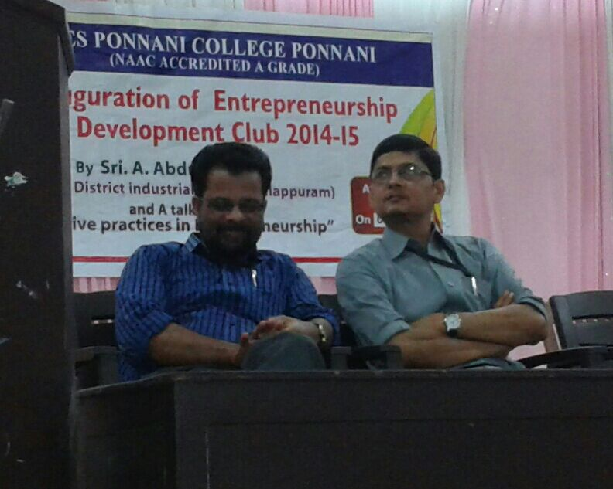

Programmes conducted as a part of M E S Golden jubilee celebrations:

E D Club in collaboration with Commerce Department conducted a QUIZ programme “BOOK” on 24th October 2014. Mr. Vineeth and Mr. Roshan were the quiz masters. 140 students attended the preliminary round and six teams consisting of two entered in final round. Shameema Raihan and Asif .K. V of Vth semester Bcom were bagged the first prize.

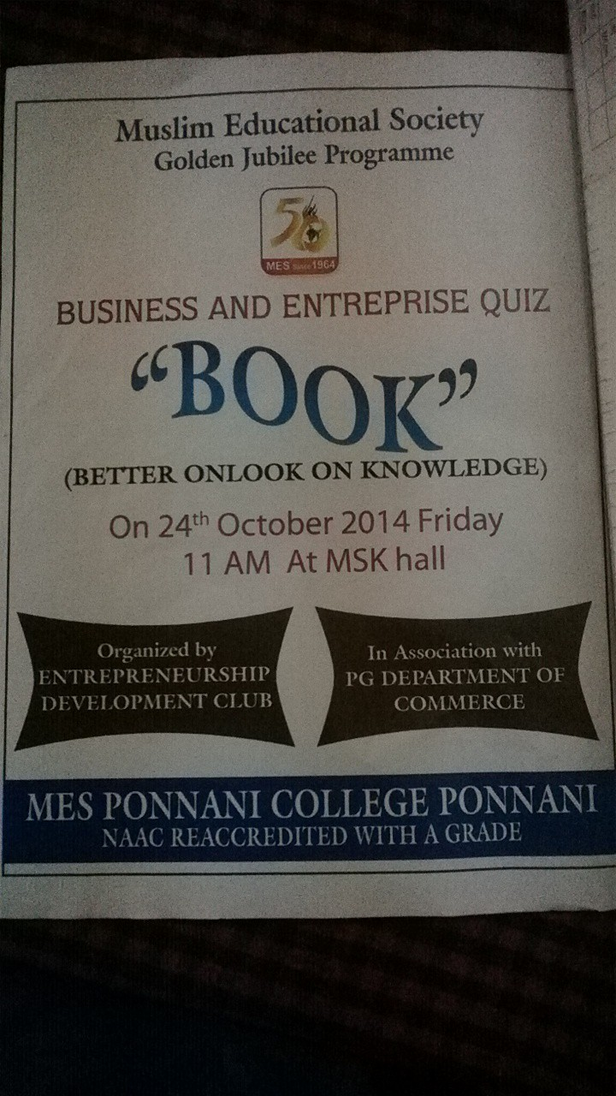

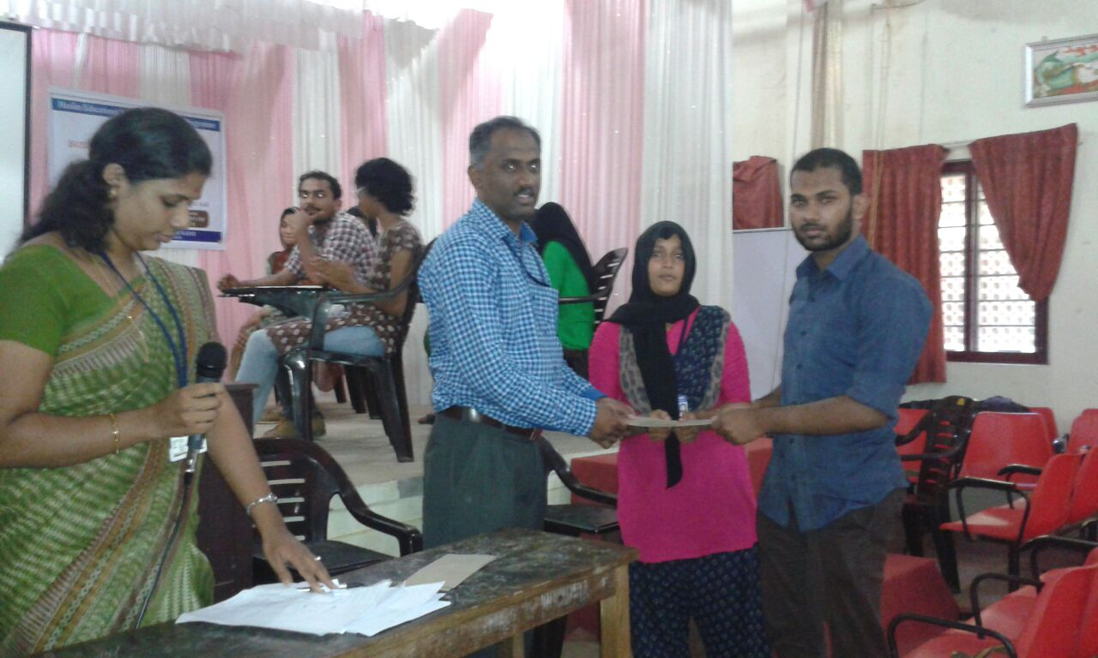

As a part of E D Club programmes, Muhammad Wafi and Muhammad Muhsin of IV semester B com participated in the training programme arranged by Kerala Institute of Entrepreneurship Development, Ernakulum on 24th and 25th November 2014.

Two students from the ED Club were attended a seminar conducted by Malappuram District Panchayath for the development of entrepreneurial skills of the students.