2016-17

ED Club, MES Ponnani College, Ponnani South in association with KITCO LTD KOCHI organized an Entrepreneurship Awareness Camp from 03-10-2016 to 05-10-2016.

On 03-10-2016 in 1st session the program was formally inaugurated by The Principal, Dr.T P Abbas, MES Ponnani College.In his inaugural address spoke about objectives of EAC. The welcome address was delivered by Sri. N P Muhammed Jaish, ED Club Coordinator, MES Ponnani College. Around 60 students of different streams attended this entrepreneurship awareness camp.

On 03-10-2016 in Second session Sri Programme Coordinator Kitco Ltd Kochi delivered the motivational talk, strategy of business and communication skill. In Third session Smt Smitha P Assistant Industrial Officer District Industries Centre Ponnani spoke about the role and Schemes of District Industries Centre, SSI unit and Business center registration formalities etc,.

On 03-10-2016 evening session students interact with Sri.Abdul Khayoom Managing Director (Secretary Chamber of Commerce), National Bakery and Bakery products, Ponnani. He spoke about how to become a successful entrepreneur. He shared his experience in business to ED students.

On 04-10-2016 as a part of EAC a factory visit was organised to Benzy food & Beverages Pvt.Ltd and Benzy printing bureau, Ponnani near to MES Ponnani College. Around 60 students along with ED Club Coordinators Prof. Siji Verghese and Prof. N P Muhammed Jaish visited there. They showed the product processing of Food and Beverages. The visit was a live experience to the students.

On05-10-2016 in first session Sri P.A Kuriachan Programme Coordinator, Kitco Ltd Kochi delivered a speech on the qualities of entrepreneurs. In second session Sri P P Madhavan Nambudhiri Financial literary Councilor ,Malappuram delivered the speech about various types of schemes and banking support to entrepreneurs in EAC. . In Third session Sri E J Anand Librarian, Senior Librarian ,Kitco Kochi delivered a lecture on Project identification,Business opportunities and technological assistance from other institutions.

The main objective of the Camp was to make the students aware about the different areas of skills where they can establish themselves as Entrepreneur and create the job for others. At the concluding session, Camp was evaluated by two students Ms. Raihanath and Mr. Zainudheen.The Principal Dr. T P Abbas inaugurated the Valedictory Function and also distributed course certificates to the participating students .Sri. Jahfar A (Assistant Coordinator, EDC) deliver the vote of thanks .Let us extend our sincere thanks to chief coordinators Sri.Dileepkumar.K and Sri P.A Kuriachan who took initiative for organising EAC in Mes Ponnani College,

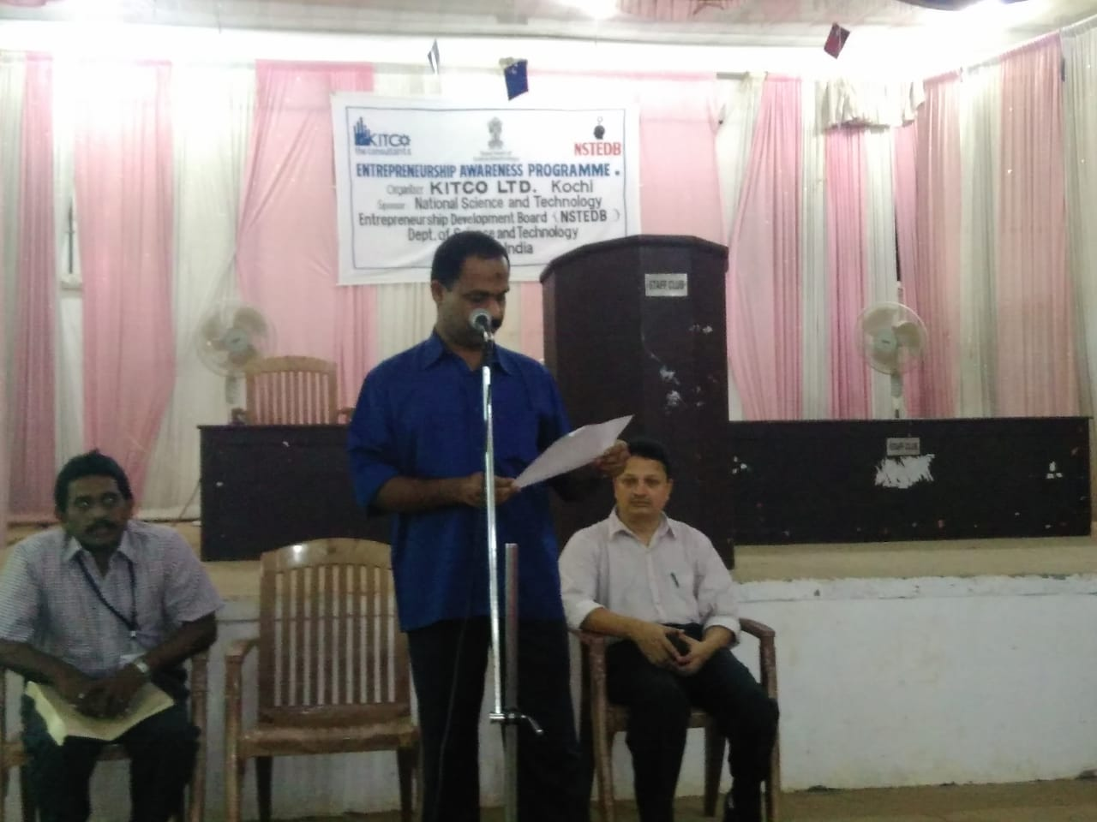

On 03-10-16 Welcome address delivered by Prof. N P Muhammed Jaish in EAC organised by Ed club and Kitco at MSK Hall in MES Ponnani College.

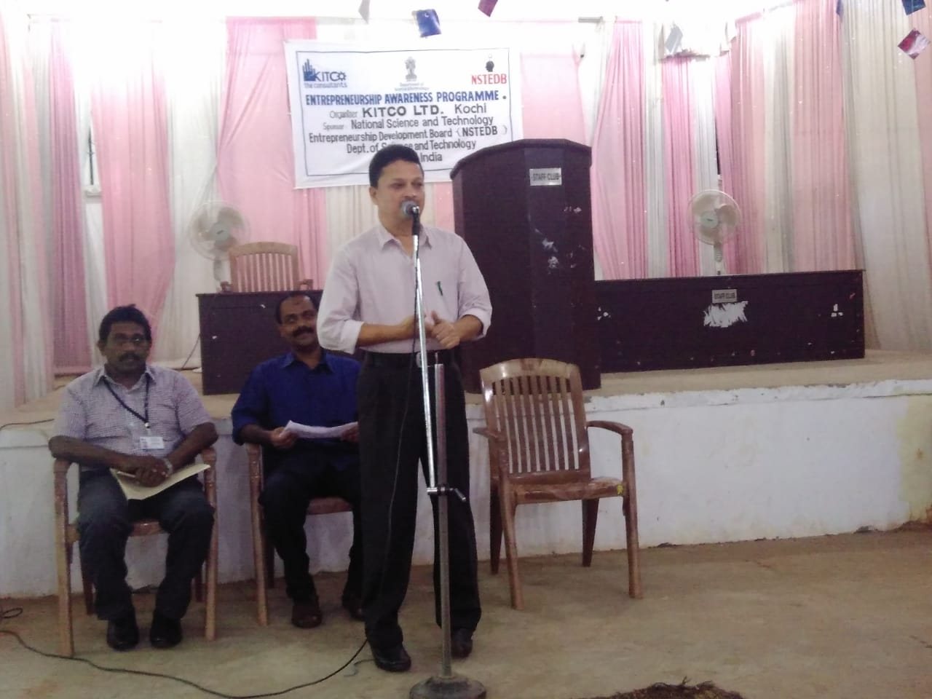

On 03-10-16 Dr T P Abbas ,Principal,MES Ponnani College inaugurate the EAC at MSK Hall in MES Ponnani College.

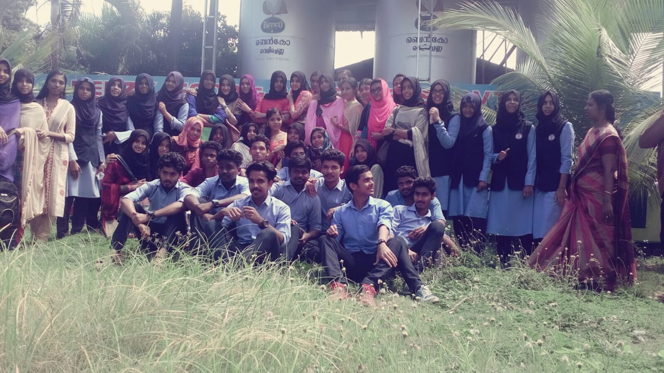

On 05-10-16 A factory visit organised by ED Club as a part of EAC conducted by KITCO

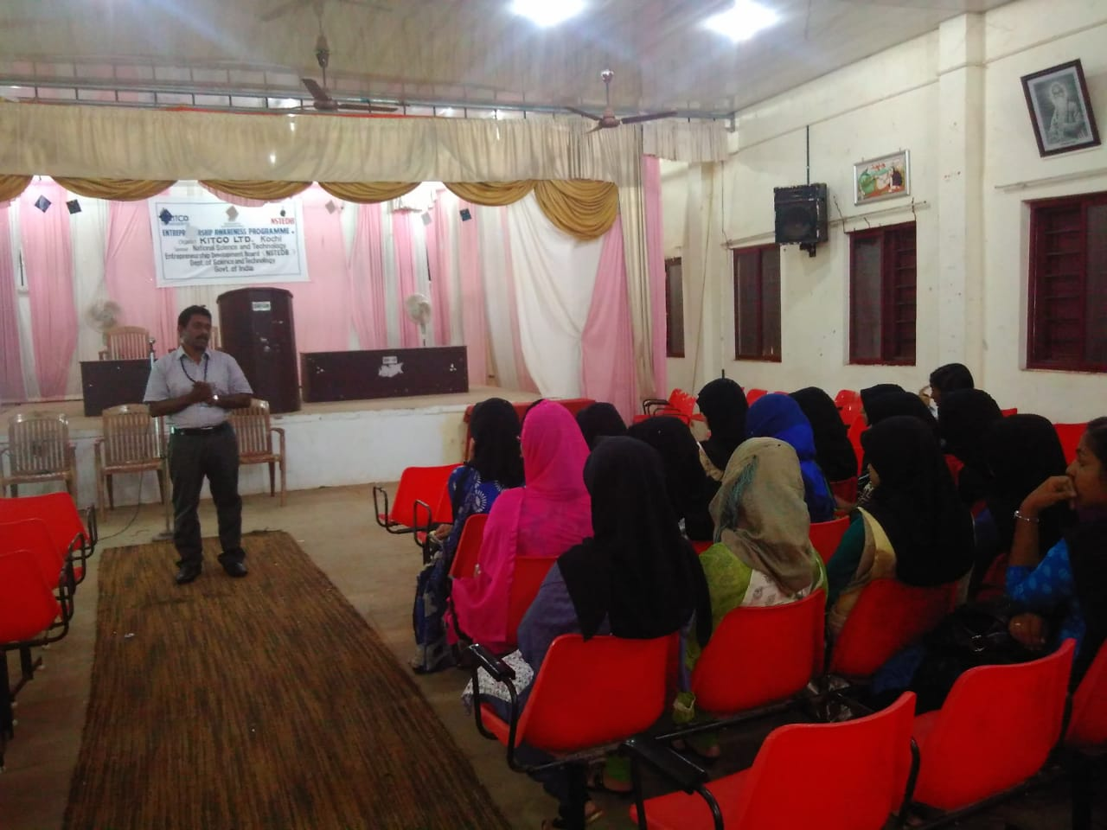

Sri Dileep Kumar Programme Coordinator Kitco delivers motivational class in EAC at MSK.