2017-18

ED Club, MES Ponnani College, Ponnani South in association with KITCO LTD KOCHI organized an Entrepreneurship Awareness Camp from 14/12/2017 to 16/12/2017.

On 14/12/2017 the program was formally inaugurated by The Principal, Dr.T P Abbas, MES Ponnani College. The welcome address was delivered by Smt. Muneera K, ED Club Coordinator, MES Ponnani College. Around 125 students of different streams attended this entrepreneurship awareness camp.

Sri E J Anand Librarian, Kitco Kochi delivered a lecture on Camp Objective and Business Opportunities Identification. Sri V.Balakrishnan Financial Literacy Councillor Perinthalmanna spoke on the topic Banking schemes and Loan Formalities, Digital Banking related to entrepreneurship.

In forth session Sri P.A Kuriachan Programme Coordinator, Kitco Ltd Kochi delivered a speech on the topic Source of Technology assistance from other Institutions.

As a part of EAC a factory visit to Benco Coconut oil Pvt.Ltd near to MES College Ponnani on 15.12.17 was organized. Around 100 students along with ED Club Coordinators visited it. They showed the process of the product of Benco coconut oil. This visit was a good experience for the students.

On 16.12.17 Sri.Dileepkumar.K Programme Coordinator Kitco Ltd Kochi delivered the motivational talk.In third session Smt Smitha Industrial Extension Officer District Industries Centre Ponnani spoke about the role and Schemes of District Industries Centre, SSI unit and Business center registration formalities Startup projects.In forth session students interact with Sri.Abdul Khayoom Managing Director Secretary Chamber of Commerce, National Bakery and Bakery products, Ponnani. He spoke about how to become a successful entrepreneur.

The main objective of the Camp was to make the students aware about the different areas of skills where they can establish themselves as Entrepreneur and create the job for others. At the concluding session, Camp was evaluated by two students Ms. Raihanath and Mr. Zainudheen.The Principal Dr. T P Abbas inaugurated the Valedictory Function and also distributed course certificates to the participating students .Smt. Fathima A V (Assistant Coordinator, EDC) deliver the vote of thanks .Let us extend our sincere thanks to chief coordinators Sri.Dileepkumar.K and Sri P.A Kuriachan who took initiative for organising EAC in Mes Ponnani College.

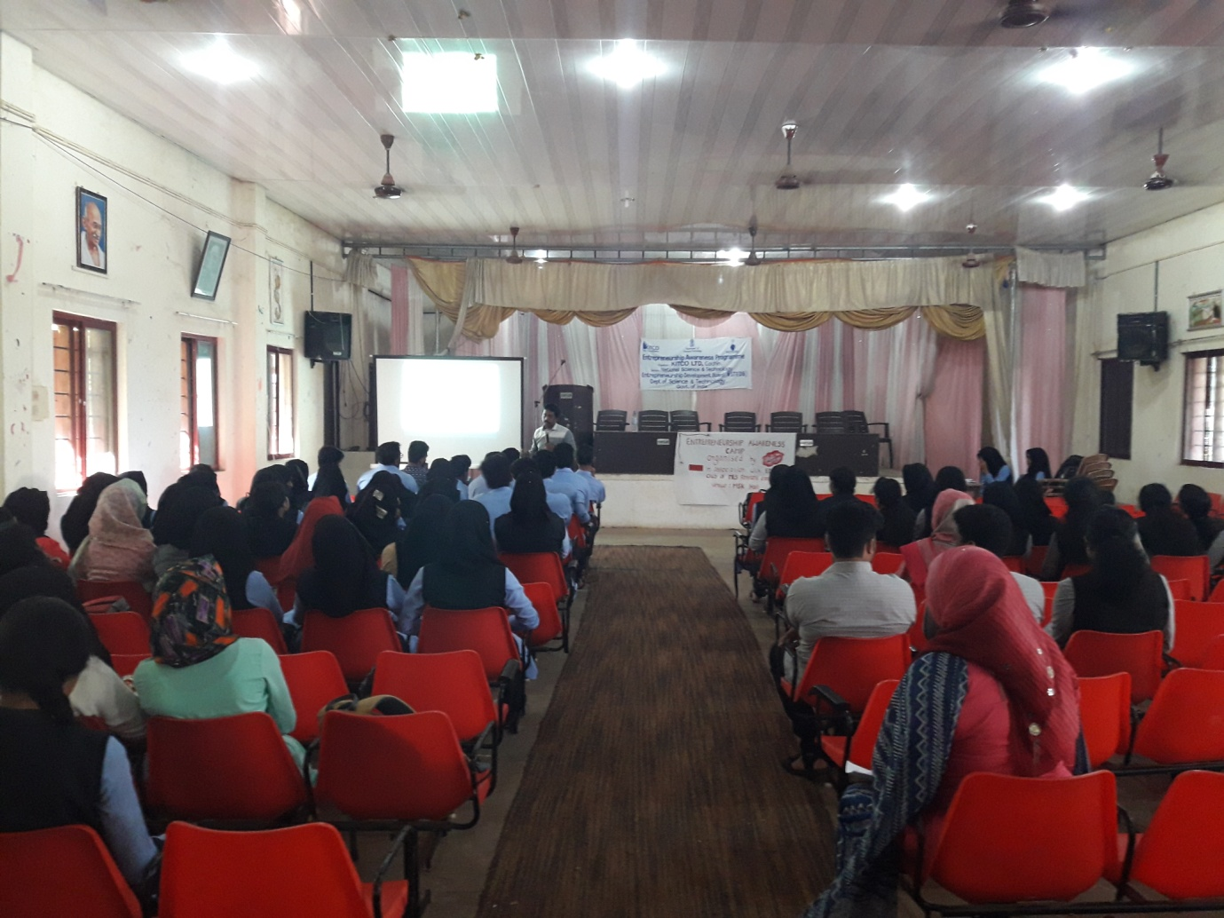

0n 16-12-2017 Sri Dileep Kumar K deliver the motivational talk to ED students in EAC at MES Ponnani College.

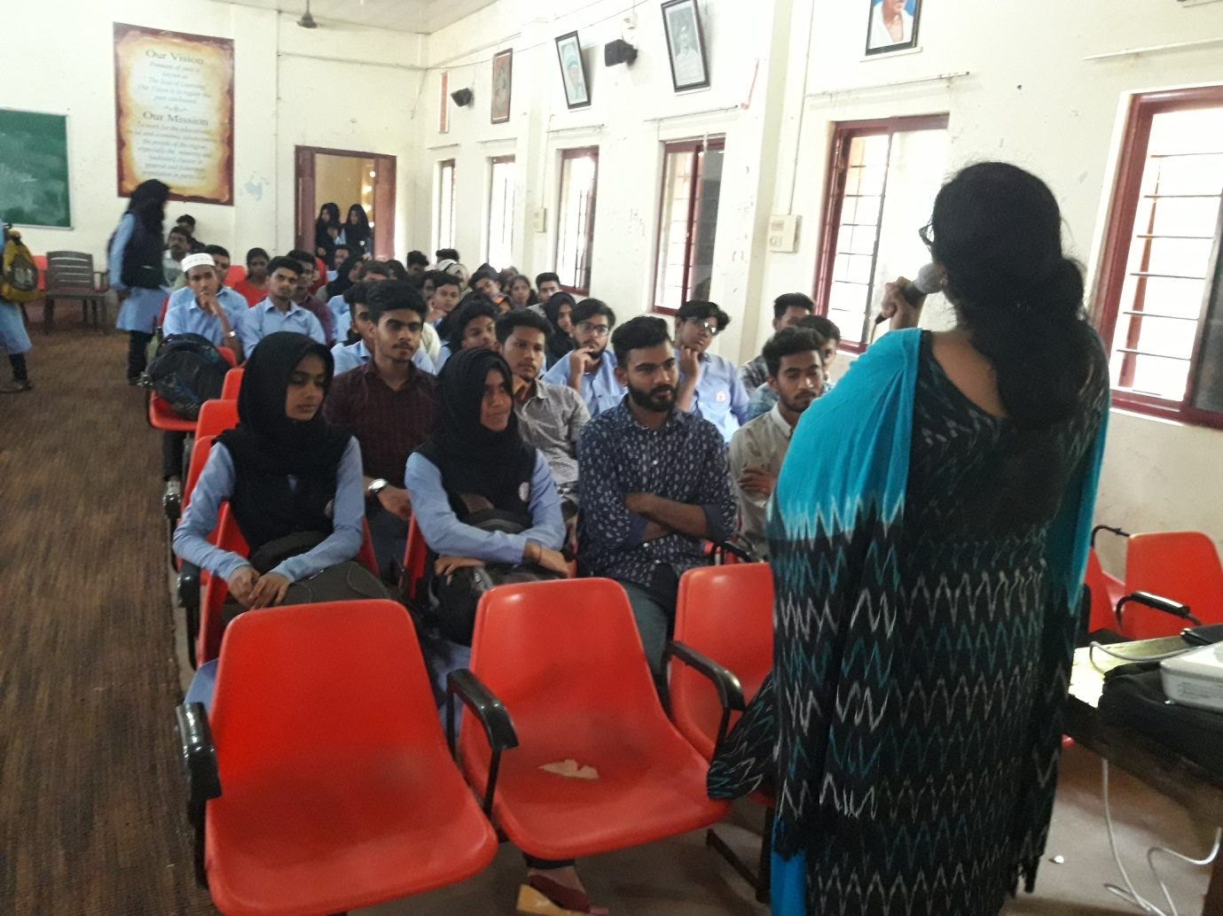

On 16-12-2017 Smt.Smitha P (Asst Industries Officer,DIC,Ponnani) deliver the speech about role and schemes of DIC and registration formalities of start up projects to ED students in EAC.

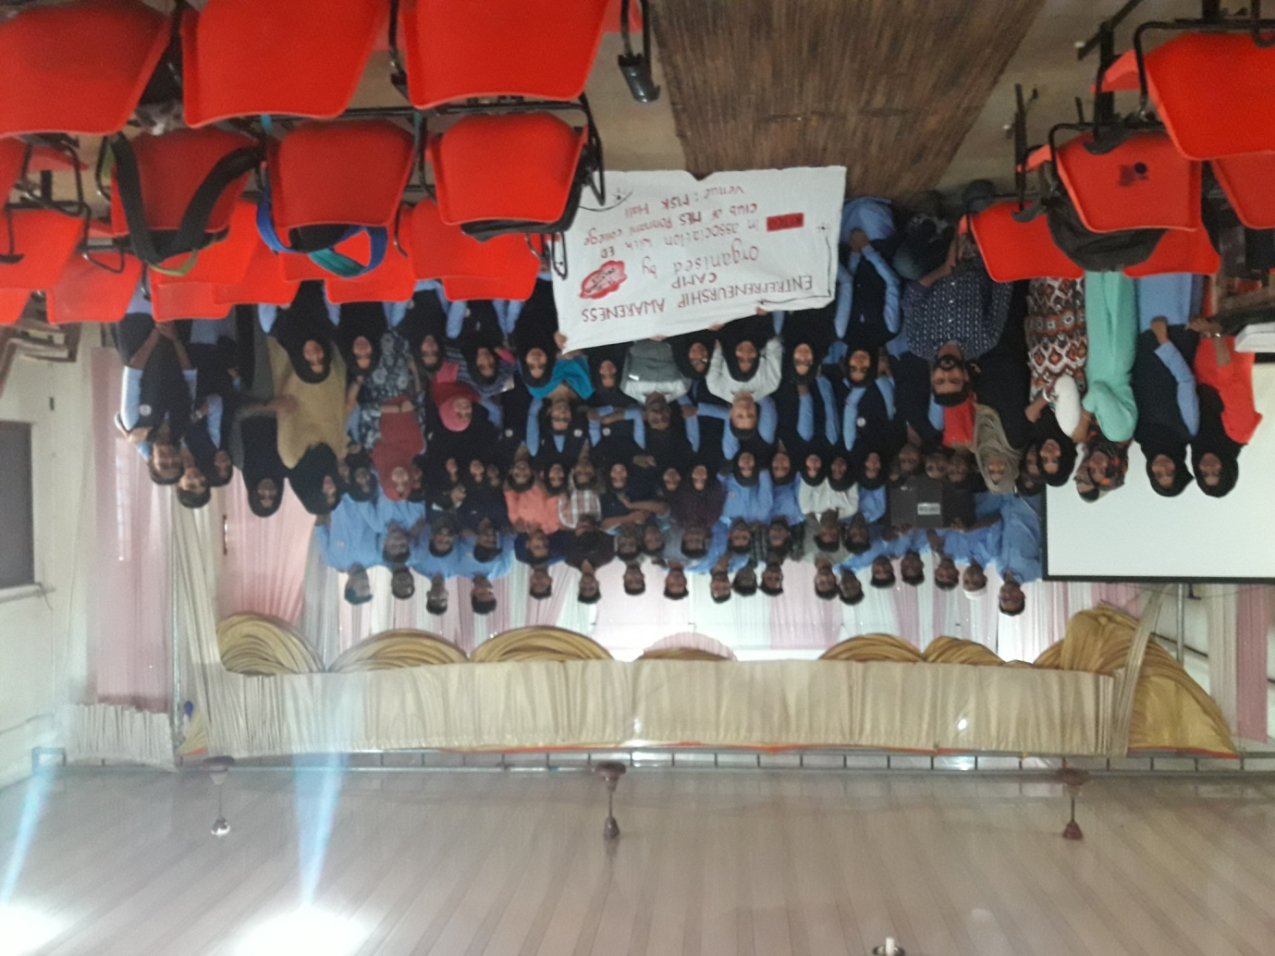

Validectory funcion of EAC organised by KITCO along with ED club at MES Ponnani College on

16-12-2017

v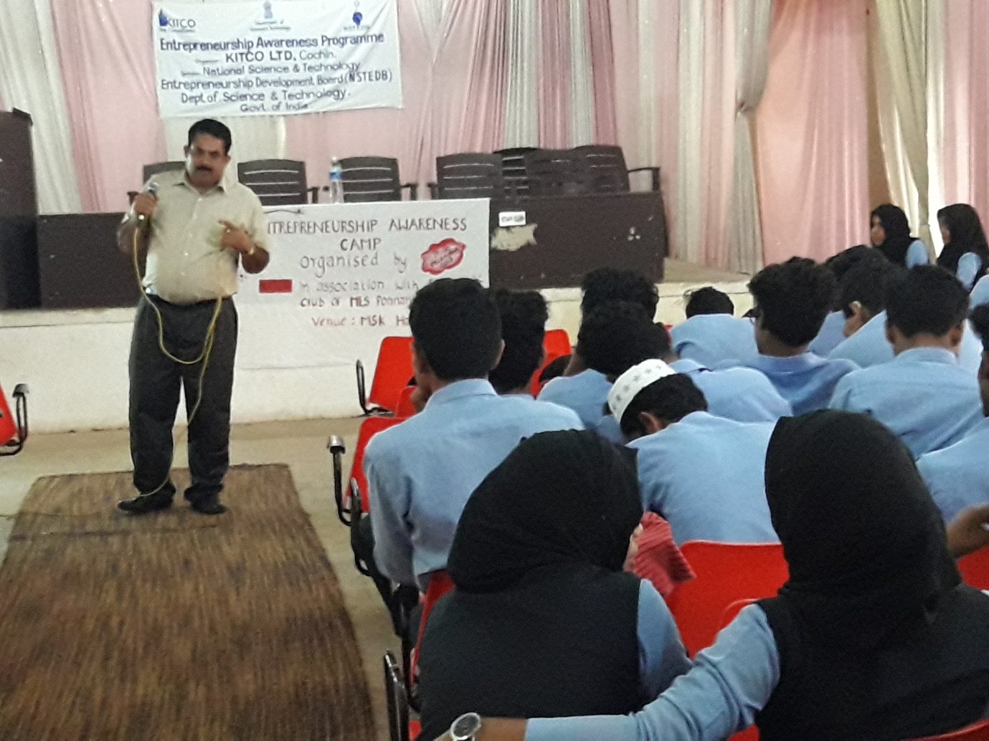

On 14-12-2017 Sri P A Kuriachan deliver the speech about source of technology assistance to start a business unit to ED members in EAC at MES Ponnani College.

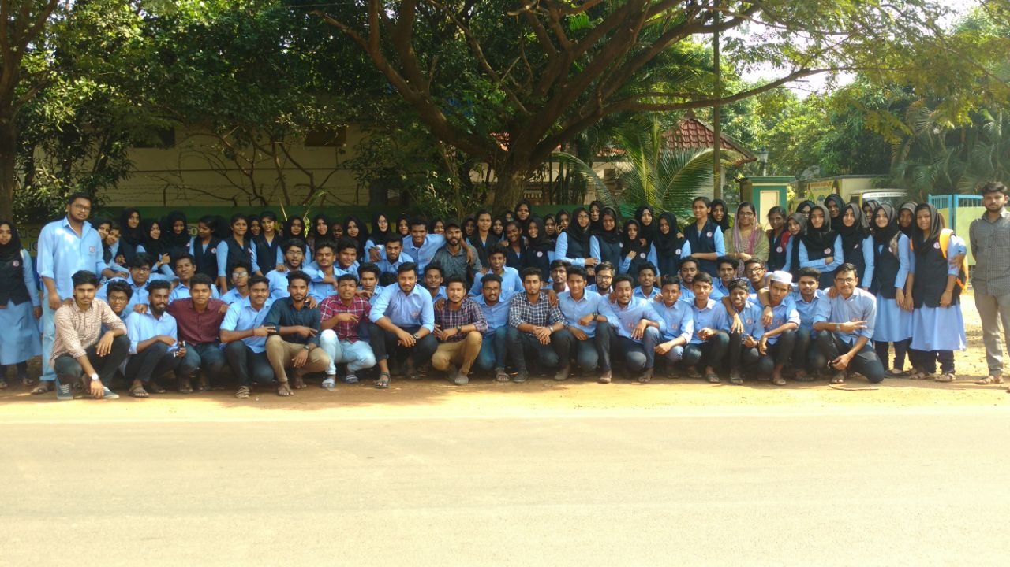

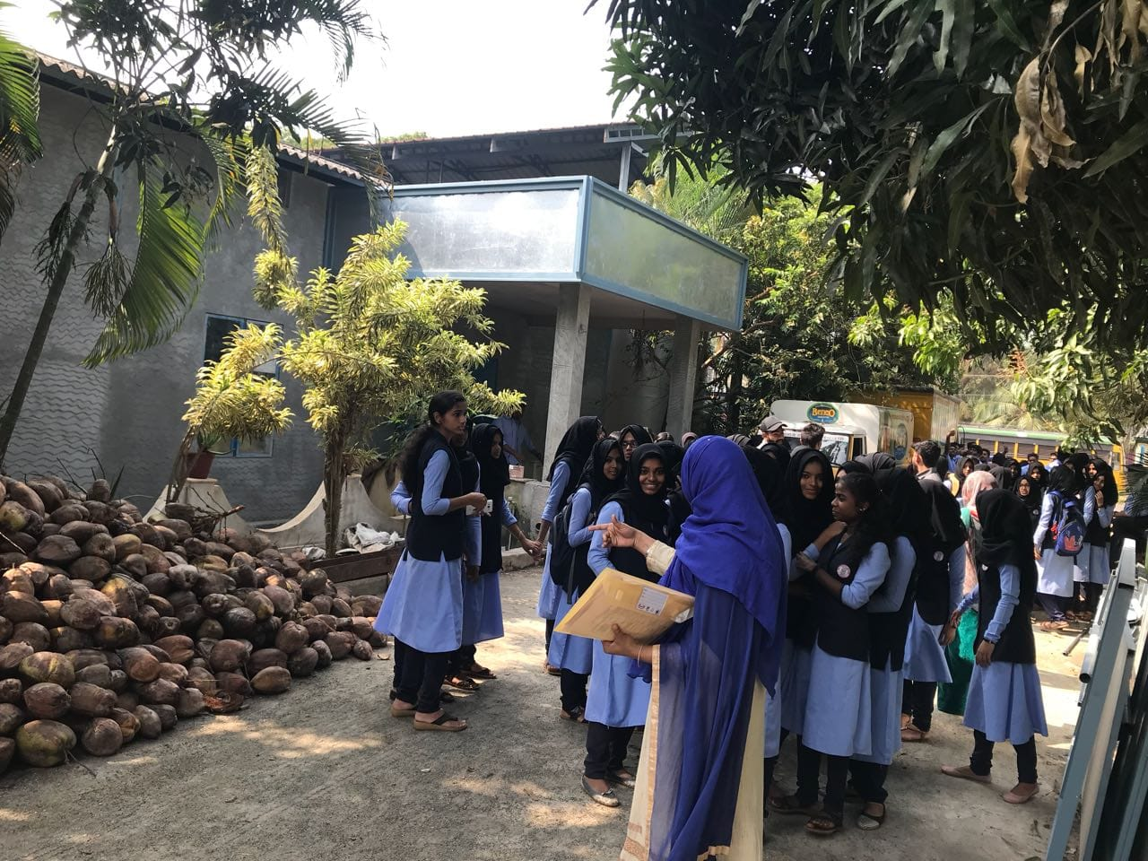

industrial visit organised by ED club on16-12-2017 to BENCO PRODUCTS Ponnani.