2018-19

ED Club activities was inaugurated by Prof. Moideen kutty parayil(Former HOD, PG Dept of Commerce ) on 1st October 2018 and a seminar on “Strategies for developing enterpreneurial skill” was conducted on the same day. In this Programme Principal Prof. M N Muhammed Koya was taken over presidential address. ED Club Coordinator Prof. Muneera K was delivered the welcome speech. The Topic was presented by Dr. Sreedharan T K(Retired Faculty, PG Dept of Commerce). Prof Fathima A Vwas delivered the vote of thanks.The seminar was very useful for students.

On 27th November 2018 ED members were participated in one day Enterpreneurial skill development Work shop conducted by PG Dept of Economics.

On 01-01-19 nine ED members started online marketing of shawls website launched named AZALEA BOUTIQUE was inspired by enterpreneurship awareness camp organised by ED club on14-16 December 2017.



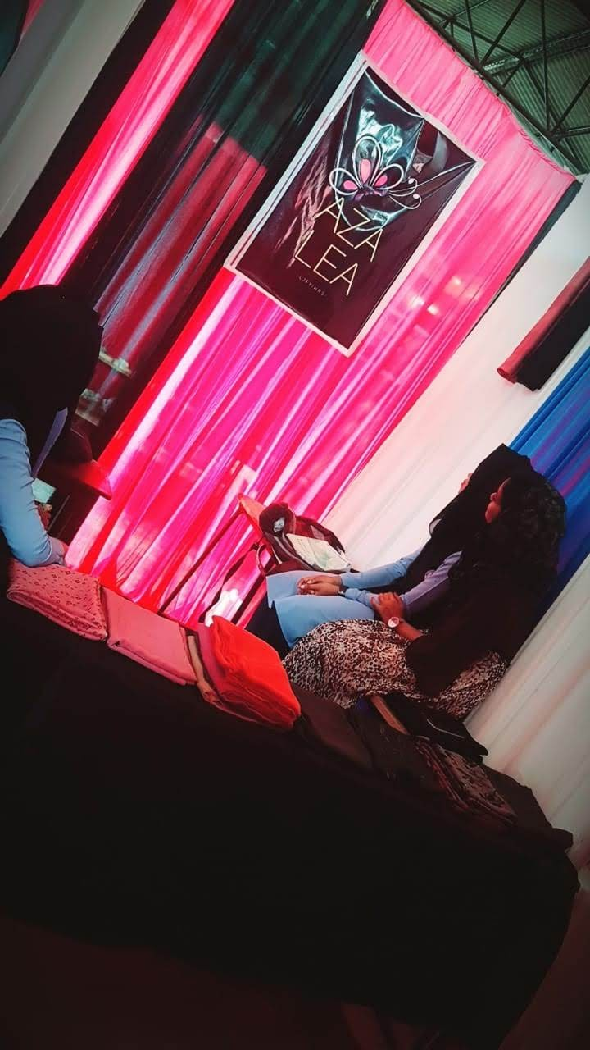

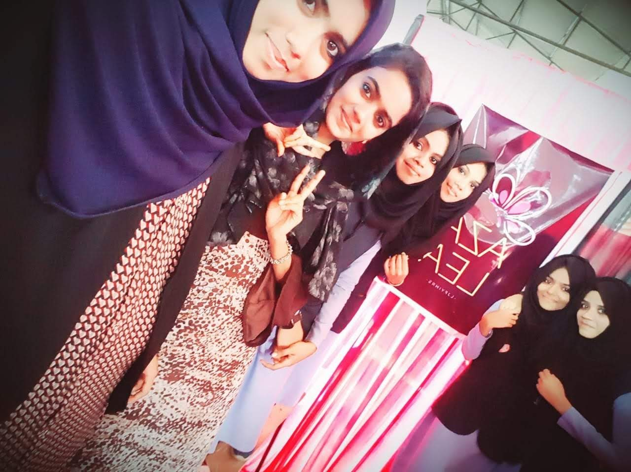

On July 30,31st &august 1st 2018 ED members set two stalls under the initiation of ED club in Science Expo named sci fari was organised by Dept of Zoology.